Introduction to Software Engineering

**Date: 29/03/2023**

**Submitted to:**

**Mam Isma Ul Hassan**

**Submitted by:**

**Noor Ul Baseer** **22I-2405**

**Shahzaib M. Akram 22I-2450**

**Haris Khan 22I-2673**

**Abdullah Khan 22I-2600**

**SE-A**

**Assignment 2**

**Table of Contents**

**UI Designs on Figma** 1

**Login and Signup Pages** 1

**User Feed, Notifications and Live Chat Pages** 2

**Payments Wallet Page** 3

**Product Description, Review and Cart Pages** 4

**Shipping and Billing Address Pages** 6

**Order Tracking** 7

**Trello** 8

**Snapshot-1** 8

**Snapshot-2** 9

**Snapshot-3** 9

**Snapshot-4** 10

**Sprint Burn-down Chart** 11

**Planning of Sprint 2** 11

**GitHub Repository** 12

**Sprint 1 Work Distribution** 13

**Ecommerce Mobile Application Development**

# **UI Designs on Figma**

**Login and Signup Pages**

* The first page to the left is the Login page where users would enter the email and password to get into their account. There we also have included the option for Forgot Password and Creating a new account.
* The second page next to the Login page is the Forgot Password page where users can enter their email to get a password reset link, in case they forgot their account password. There is also an option to get back to the login page.
* Next to it is the Signup page for buyers where users will enter their personal details and create their account. There is also option for moving back to the login page and for Creating an Account as a Seller.
* At last we have the Create an Account as a Seller page where a seller would create his account and register his business for selling his products. There is also the option to move to the login page.

## **User Feed, Notifications and Live Chat Pages**

* At left is the Side Menu page that shows some functions a user can perform on his account.
* Next to it is the User Feed page that shows the products to the user based on his browsing and search history. At the top left is the button for the side menu and on top right are two buttons for viewing the notifications and cart page. At the bottom are the buttons for moving to the Wallet, Wishlist and Live Chat Pages.
* Next to the user feed page is the Notifications page where users will get the notifications that are sent to their accounts, like for order conformation, or when their order has departed from the store. On the top left is the button for m0ovung back to the feed page.
* Next to it is the Searching Products page. There is a search bar on the top where the text would enter as the user types in. Next to the search bar, to the left is the option for moving back. There is also an option for filtering the search results.
* Last is the Live Chat page where buyers and sellers can interact 24/7 and buyers can know about the products from a close view.

## **Payments Wallet Page**

* To the left we have the Payments Wallet Home page. Where users can view their current balance at the center. At the top left there is the button for the notifications page where the user will get notifications related only to the payments. At the bottom is the My Transactions menu that will show the past transactions that were made through the payment’s wallet. Bottom to it is the menu that has the button to take user to the Cards page.
* To the right is the Cards page where user can view the existing cards linked to the account and bottom to the cards is the option for adding a new card where the user would enter his card details and proceed for verification.

## **Product Description, Review and Cart Pages**

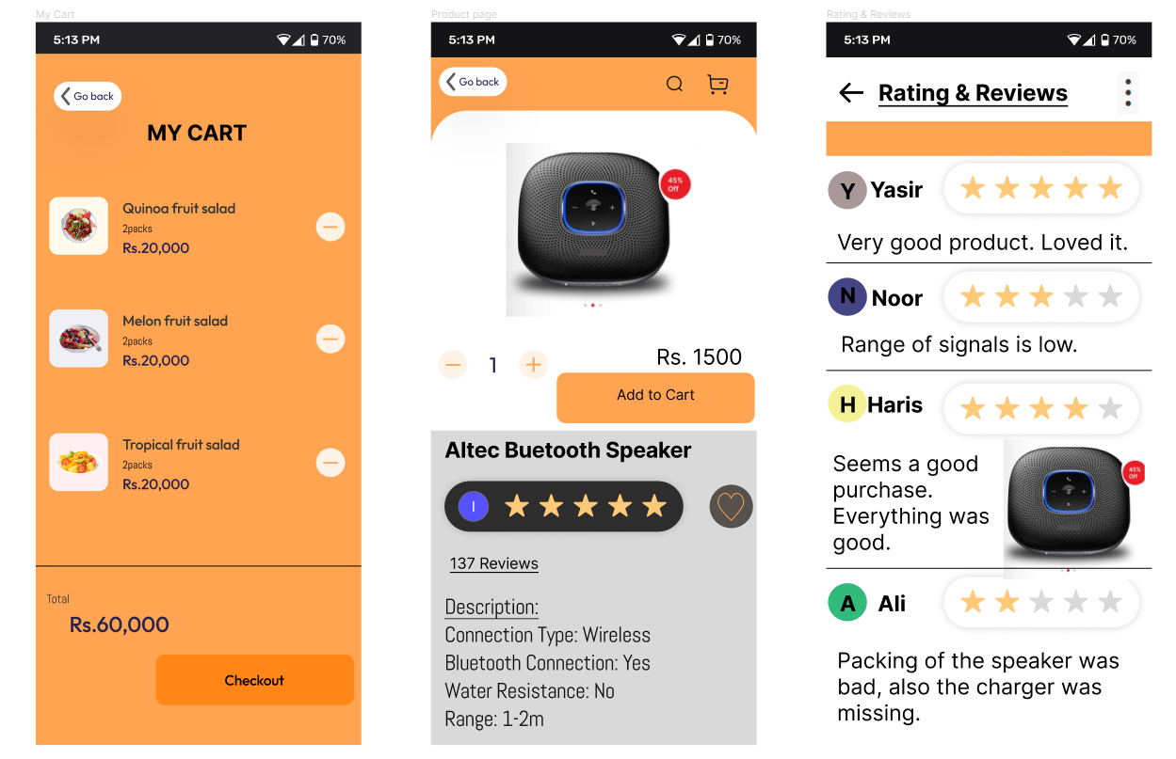

* To the left, we have the Cart page that will show the user the items that he would have added to the cart. The user has the option to remove the item form the cart, to the right of the item. At the bottom, the user would get the total amount of items in the cart and the button to move to the Checkout page for completing the order.
* At the center is the Product Description page that shows the images of the product and the option for adding it to the cart with having an option to control the quantity of items added to the cart. Right after the Cart button, we have a description of the product. The user will have the option to give a rating to the product and the option that shows him the number of ratings already given to the item. By clicking those rating quantity, the user would move to the rating page.
* At left is the Rating and Reviews page where the user will see all the reviews given by other users that may have purchased that item.
* 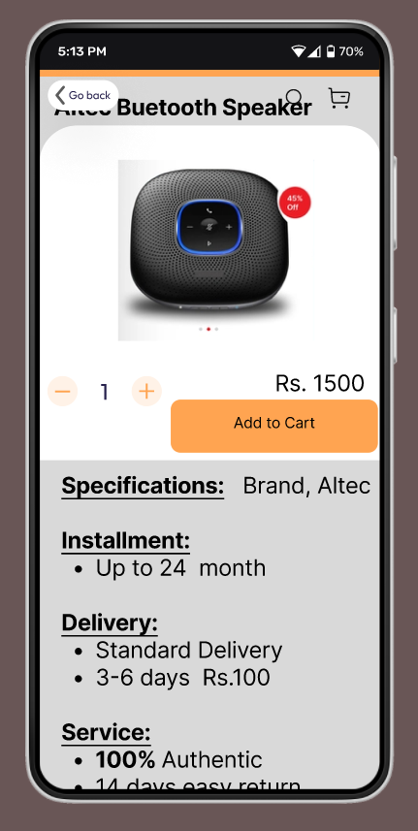This is again the Product Description page, but this is showing the page scrolled halfway that has the further description of the product.

## **Shipping and Billing Address Pages**

* On the left is the Billing Address Page, where the user will enter his address to get the bill delivered. There is the user also has the option of automatically filling in the shipping address same as the billing.
* In the center is the Shipping Address page, where the user will have to enter the address to which he wants his product to be delivered.
* On the right is the Billing Summary page, where the user will have a look at his product details that he is about to purchase. There the user has two options for making a payment, Paying Now and Paying Later. In Pay Later, the user has the option to pay the amount in easy monthly installments.

## **Order Tracking**

* 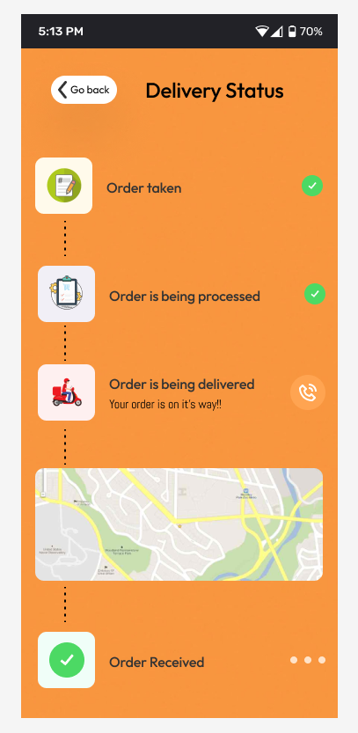This is the Order Tracking page for buyers. Here we have added the option for the users to get real-time updates of the ordered product. On the top is the status of order noted and down to it is the status of order processing and then the status of when the rider would have departed for the delivery. We have also added the option of a map for live tracking of the delivery boy. And last is the status when the buyer would know about order received update.

# **Trello**

## **Snapshot-1**

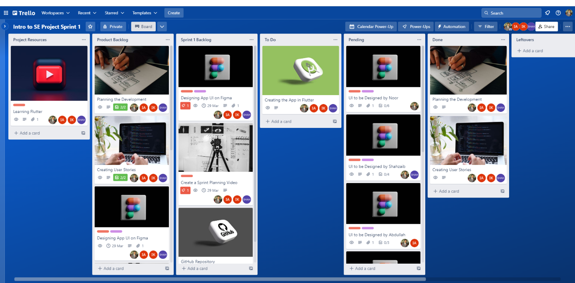

* This snapshot shows the Trello Board for Sprint 1 at the beginning of the sprint. It contains the Project Resources list that I (Scrum Master) have created and have shared some resource links for learning Flutter.
* Next to it is the Product Backlog list where the cards are added of the tasks to be done during the whole app development.
* Next is the Sprint 1 Backlog list where the cards are added of the task to be done in sprint 1. Here the UI Designing on Figma, Creating Sprint Planning video and Creating GitHub Repository cards are added.
* Then I have the To Do list which shows the task to be done in the upcoming sprints. I have added here the Creation of App on Flutter task.
* Then we have the Pending list where the cards are of tasks that are currently in progress, probably the tasks in the current sprint. Here I have added the breakdown of the UI designs that are to be designed by each member of the team.
* Next, I have the Done list which would show the task that will be completed time to time. Currently, it has Planning and User Stories creation tasks in it that were done before sprint 1.

## **Snapshot-2**

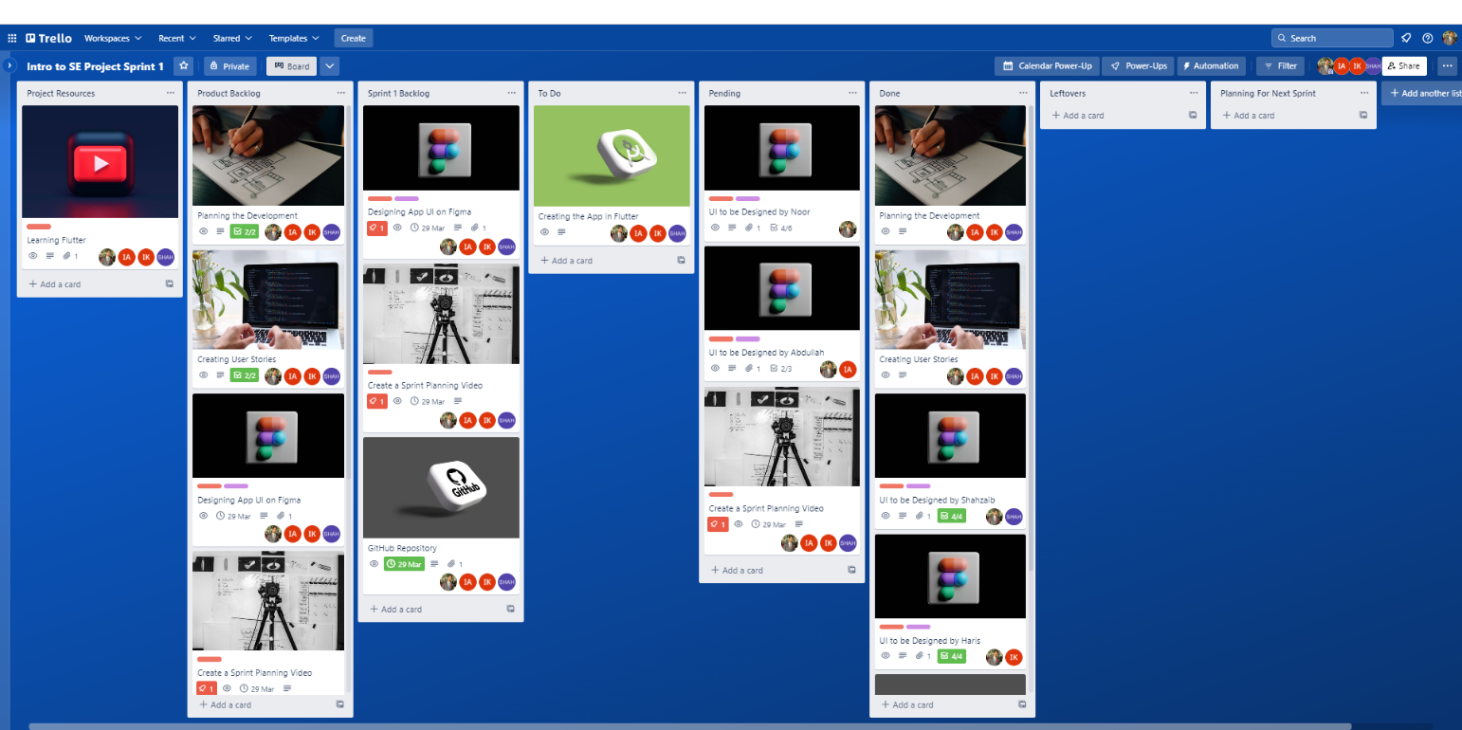

* This snapshot shows the Trello Board for Sprint 1 in the middle of the sprint. It shows the tasks that are done in the middle of the sprint.
* This board shows that some team members have completed their task, and some have completed some of their tasks.

## **Snapshot-3**

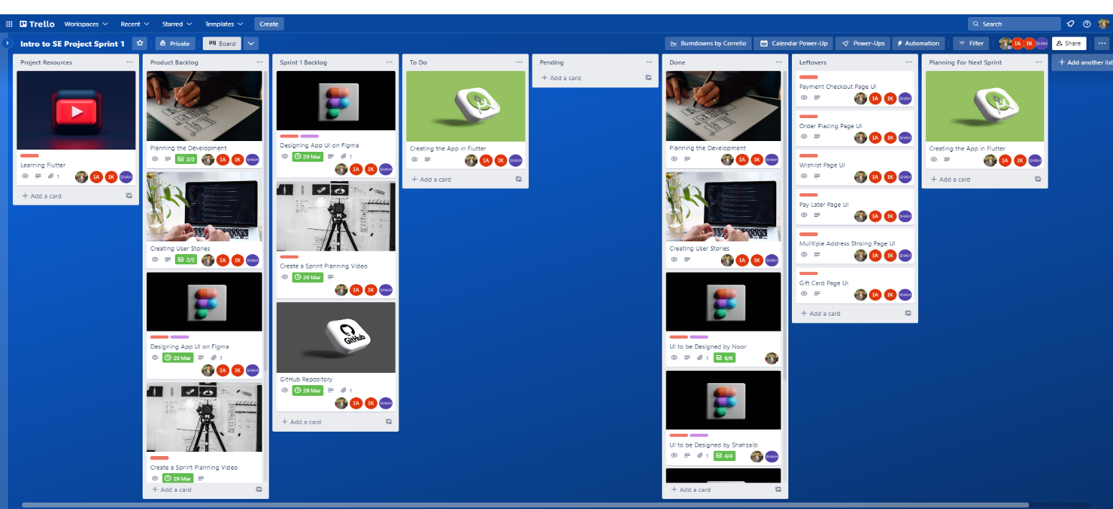

* This snapshot shows the Trello Board for Sprint 1 at the end of the sprint.
* The board shows the task in the Done list that were to be completed in sprint 1.
* There is also a Leftover list that shows some UI designs that were left in sprint 1 and are to be designed in sprint 2.

## **Snapshot-4**

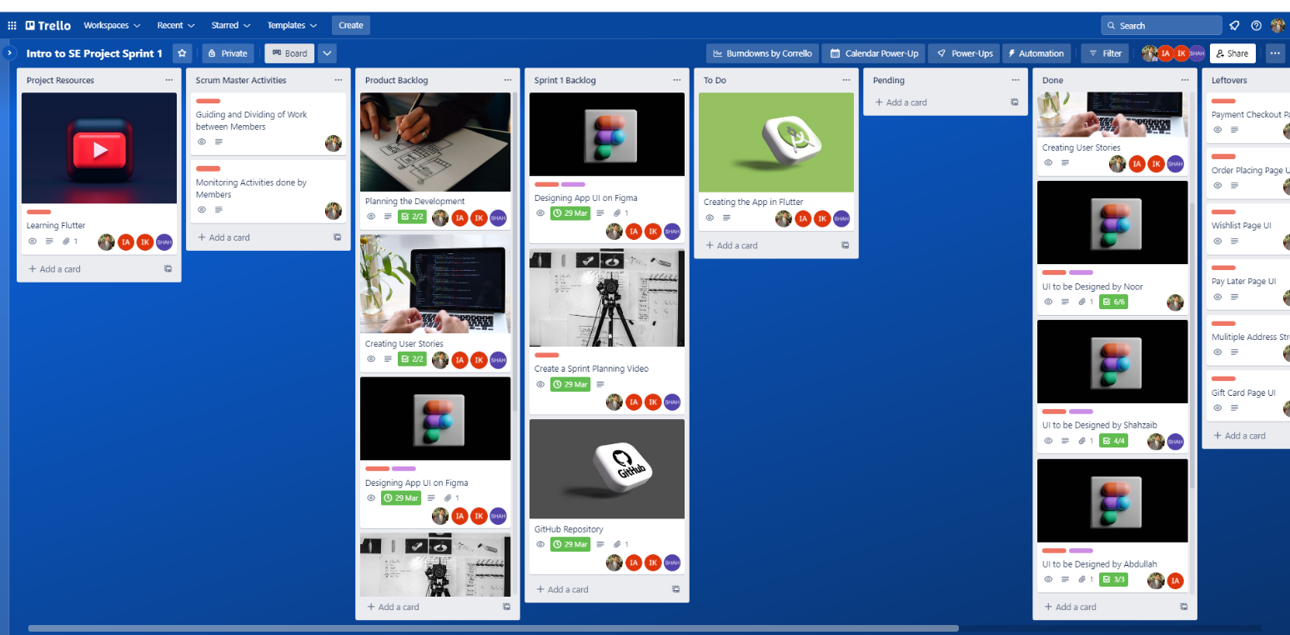

* This snapshot shows Scrum Master Activities list that has the cards for the activities performed by the scrum master. The cards include guiding, dividing, and monitoring the tasks performed by the team members.
* Further, the board has the list of Project Resources that has been added by the scrum master for sharing the resources required for the app development to the team.
* Next the divisions of UI designs shown in the Done list are also managed by the scrum master and theses cards are moved from Pending to Done by the scrum master after reviewing the pages.

# **Sprint Burn-down Chart**

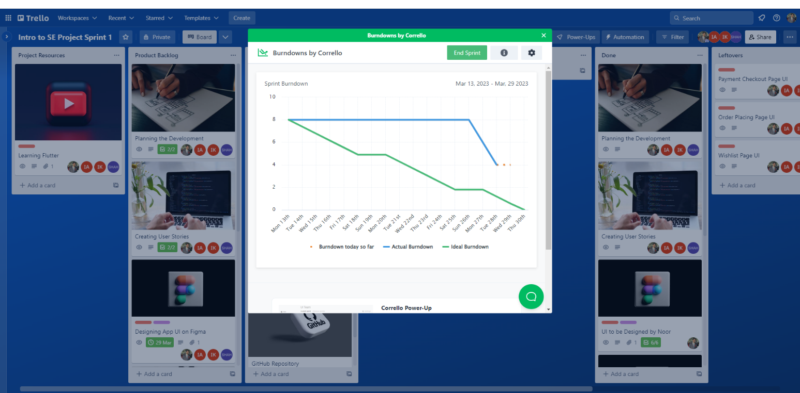

* The Sprint Burn-down Chart shows the graph of the activities that were planned to be done in the sprint 1 versus the activities that are completed in the sprint 1.

# **Planning of Sprint 2**

* We have planned to start the sprint 2 by creating the Leftover UIs of sprint 1 that are:

1. Payment Checkout Page

* As a buyer, I want to have multiple payment options available to choose from, such as credit or debit cards so that I can make a secure and convenient purchase.
* As a seller, I want to offer multiple payment options to accommodate the preferences of different buyers and to increase the likelihood of a successful purchase.

1. Order Placing Page

* As a seller using the e-commerce app, I want to be able to easily manage and fulfill customer orders so that I can maintain a high level of customer satisfaction and grow my business.
* As a buyer using the e-commerce app, I want to be able to easily place orders for the products I want so that I can receive them quickly and conveniently.

1. Wishlist Page

* As a buyer, I want to be able to save products to a wish list so that I can easily find them later and purchase or share them with friends and family.
* As a seller, I want to be able to track which products are popular among users and potentially offer promotions for those items.

1. Pay Later Page

* As a buyer, I want to buy a high-priced item, but I don't have enough money to pay for it upfront. The ecommerce app offers a financing option, which allows me to make monthly payments over time.
* As a seller, I want to increase sales by offering financing options to my customers. I partner with a financing company and add a “Buy Now, Pay Later" option to my checkout process.

1. Multiple Address Storing Page

* As a buyer, I want to be able to save multiple shipping addresses, so that I can easily choose the correct address for each order.
* As a seller, I want to be able to accurately ship orders to the correct address to ensure customer satisfaction.

1. Gift Card Page

* As a buyer, I want the option to get gift cards for myself or others as a convenient and thoughtful gifting option.
* As a seller, I want to offer gift cards to increase brand awareness and attract new customers.
* Further we plan to start implementing our UI designs on Flutter and add the features to the app that were planned before sprint 1.

# **GitHub Repository**

* Link: <https://github.com/NoorUlBaseer/Intro-to-SE-Project/tree/Sprint-1>

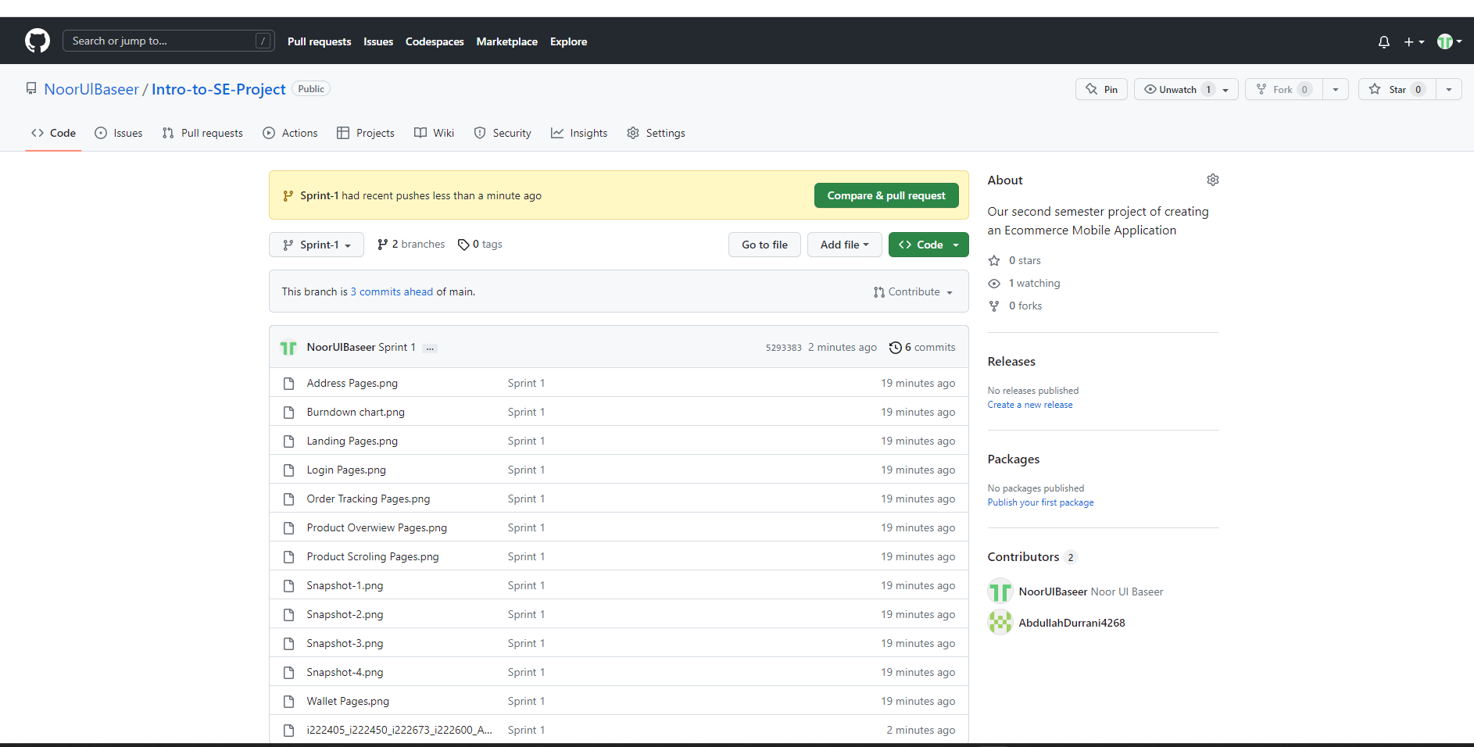

# **Sprint 1 Work Distribution**

|  |  |  |  |
| --- | --- | --- | --- |
| Noor Ul Baseer | Shahzaib M. Akram | Abdullah Khan | Haris Khan |
| Trello Board | User Feed Page | Product Description Page | Shipping Address Page |
| GitHub Repository | Notification Page | Review Page | Billing Address Page |
| Login Page | Side Panel Page | Chat Page | Billing Summary |
| Forgot Password Page | Search Page |  | Cart Page |
| Signup Page for Buyer |  |  |  |
| Signup Page for Seller |  |  |  |
| Wallet Page |  |  |  |
| Online Product Tracking |  |  |  |
| Sprint Burndown Chart |  |  |  |